R Markdown Template_FA24

Fang Bian

2024-08-21

## clean R environment

rm(list = ls(all=TRUE))  
graphics.off()  
shell("cls")

## Text

This is an example of R Markdown document.  
You can insert an R code chunk  
1. Using the RStudio toolbar (the Insert button)  
2. Keyboard shortcut Ctrl + Alt + I ( Cmd + Option + I on macOS)  
3. End a line with two spaces to start a new paragraph.

# install.packages("datasets")  
# install.packages("ggplot2")  
# install.packages("MASS")  
# install.packages("dplyr")  
  
View(iris)  
mydata <- iris  
head(mydata)

## Sepal.Length Sepal.Width Petal.Length Petal.Width Species  
## 1 5.1 3.5 1.4 0.2 setosa  
## 2 4.9 3.0 1.4 0.2 setosa  
## 3 4.7 3.2 1.3 0.2 setosa  
## 4 4.6 3.1 1.5 0.2 setosa  
## 5 5.0 3.6 1.4 0.2 setosa  
## 6 5.4 3.9 1.7 0.4 setosa

str(mydata)

## 'data.frame': 150 obs. of 5 variables:  
## $ Sepal.Length: num 5.1 4.9 4.7 4.6 5 5.4 4.6 5 4.4 4.9 ...  
## $ Sepal.Width : num 3.5 3 3.2 3.1 3.6 3.9 3.4 3.4 2.9 3.1 ...  
## $ Petal.Length: num 1.4 1.4 1.3 1.5 1.4 1.7 1.4 1.5 1.4 1.5 ...  
## $ Petal.Width : num 0.2 0.2 0.2 0.2 0.2 0.4 0.3 0.2 0.2 0.1 ...  
## $ Species : Factor w/ 3 levels "setosa","versicolor",..: 1 1 1 1 1 1 1 1 1 1 ...

# histogram   
hist(mydata$Sepal.Length)

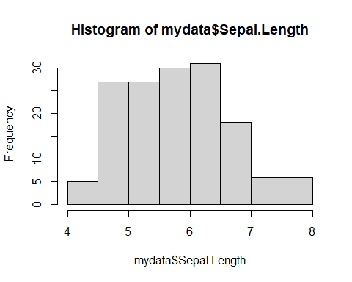

# sub-setting with “[]” and “==”

# sub-setting with "[]" and "=="  
attach(mydata)  
hist(Sepal.Length [Species == "setosa"])

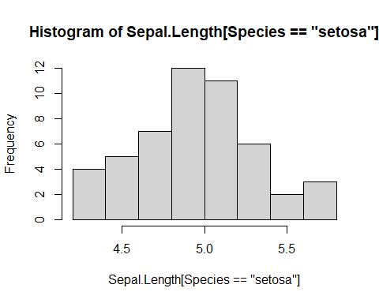

This is a histogram.

detach(mydata)

## Don’t forget to click “Knit”

# END